

WELETAW EYASU

INTRODUCTION

The Laundry Database System is designed to efficiently manage the operations of a laundry service business by utilizing a robust relational database application. This system encompasses key modules such as customer management, order processing, payment handling, and service tracking. To ensure data integrity and reliability, transaction management is implemented for critical operations like order placement and payment processing, safeguarding against data loss or inconsistency. Features such as commit, rollback, and save points are demonstrated to manage transactional workflows and handle potential failures gracefully. Additionally, the system simulates concurrent transactions—such as multiple customers placing orders simultaneously—and applies concurrency control techniques to maintain consistency, thereby showcasing the importance of isolation and synchronization in a multi-user environment.
1. Design a relational database application based on your chosen project title.

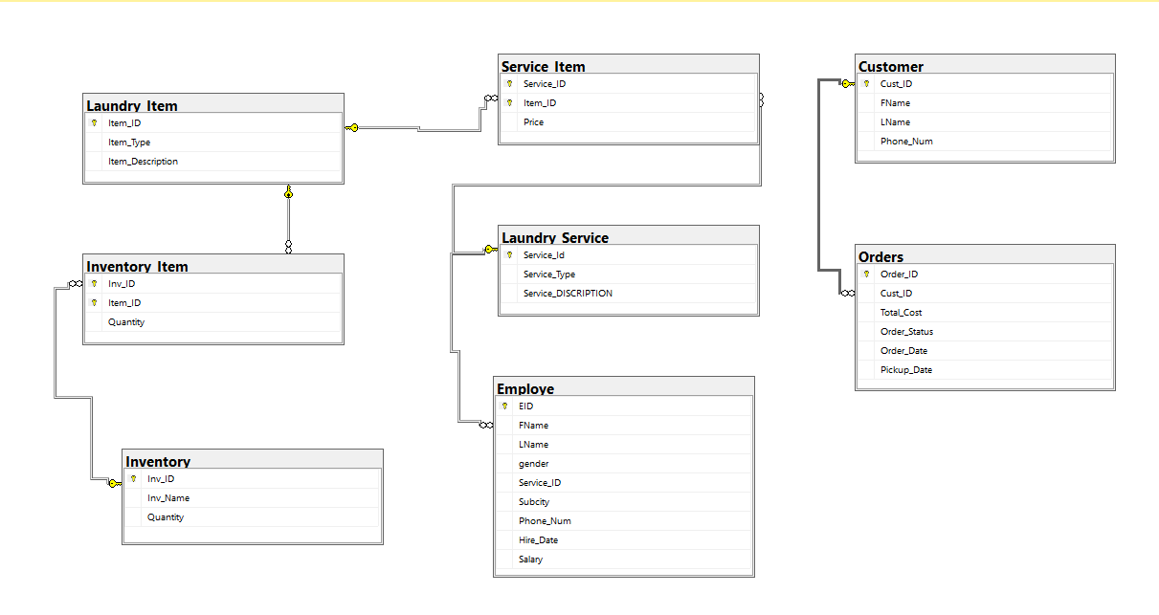
2. Implement transaction management for critical operations. For example, in bank management system , this would include fund transfer.

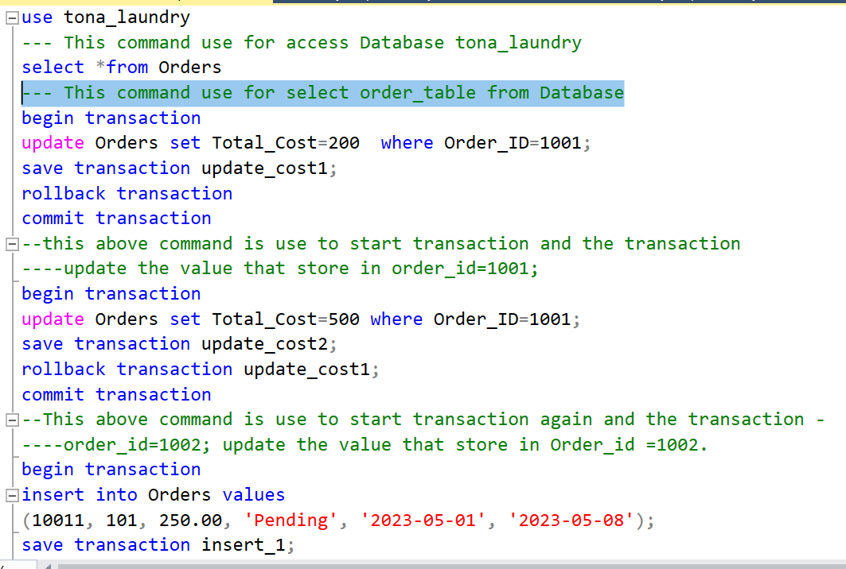
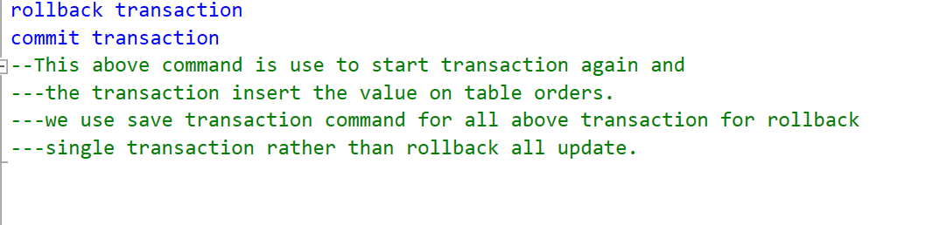

3 . Demonstrate the use of commit , rollback and savepoint . Before showing the use of commit rollback and savepoint .

*Initially the table
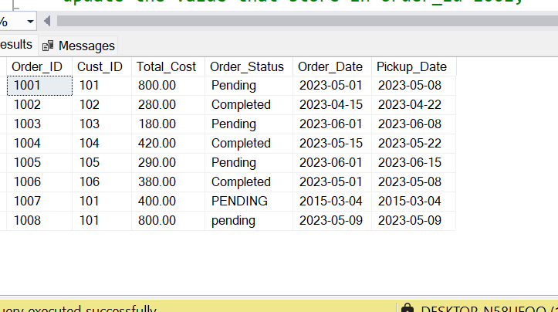

*COMMIT : - is used to permanently save all the changes made during the current Transaction to the database.
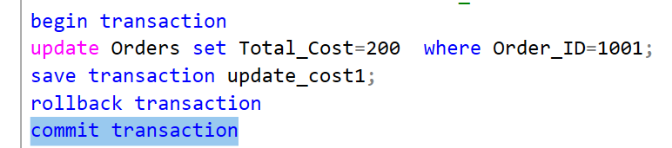

After this operation and commit the table value permanently change to below
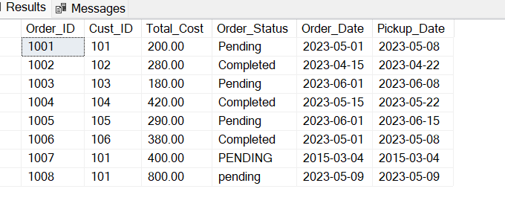
*ROLLBACK : - undoes all changes made in the current transaction , reverting
The database to its previous stable state.
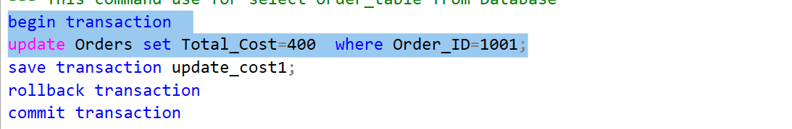
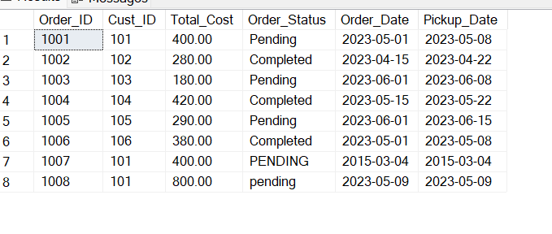
First we perform the update opration on the database value without commit the update is performed but not permanently saved so it may be rollback to previous value.
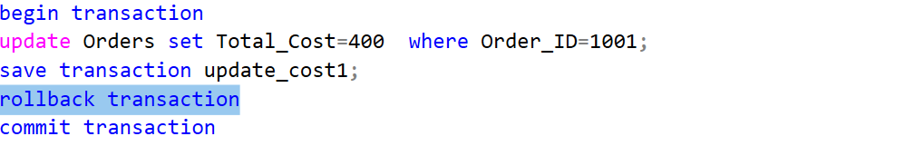
Then it back to previous values
SAVEPOINT : - sets a point within a transaction to which you can later roll Back without affecting the entire transaction.
1st transaction update and save by using save transaction
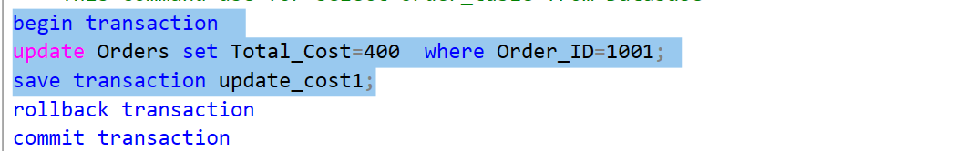
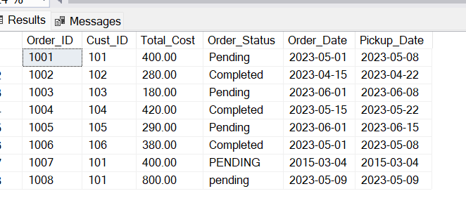

Then 2nd transaction update and save by using save transaction
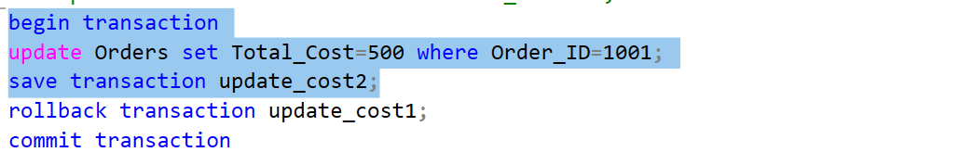
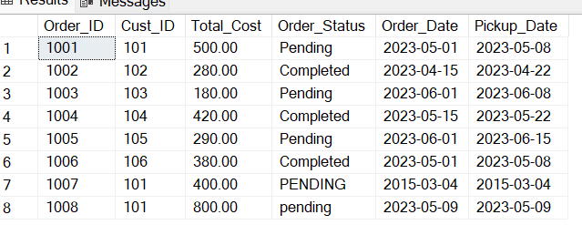
*The use of save point is to reverse the value at the 1st updated not rollback to initial condition and to undo single transaction.
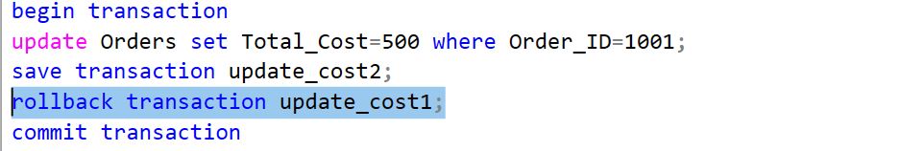
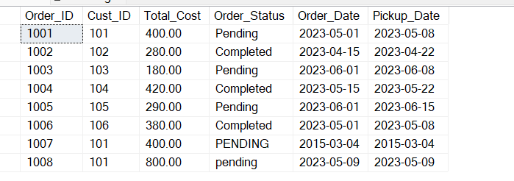

4. simulate concurrent transaction and analyze the impact of councurrency control techniques.
There are two transaction , which operate concurrently and know we see how locking operate.
CASE 1
1st transaction acquired shared lock on the item or our scenario table The same 2nd transaction acquired shared lock on the table so both can view the table because in locking base councurrency control two transaction can acquired shared lock of the same data item.
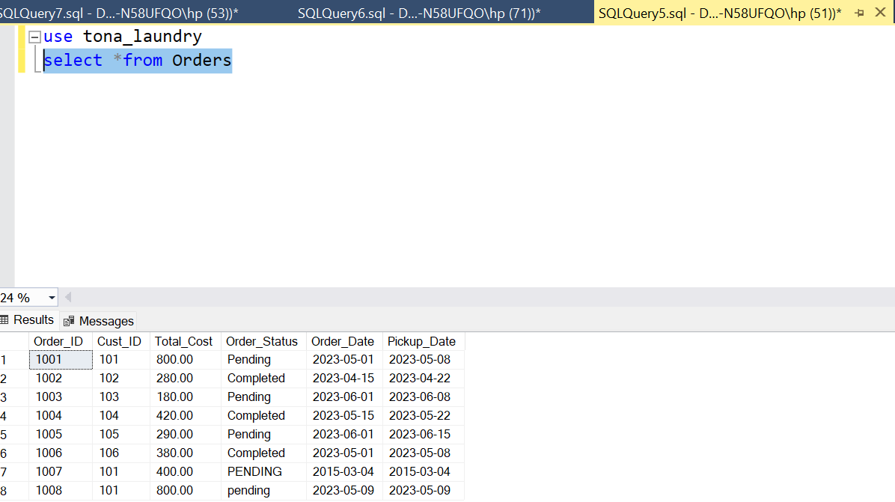

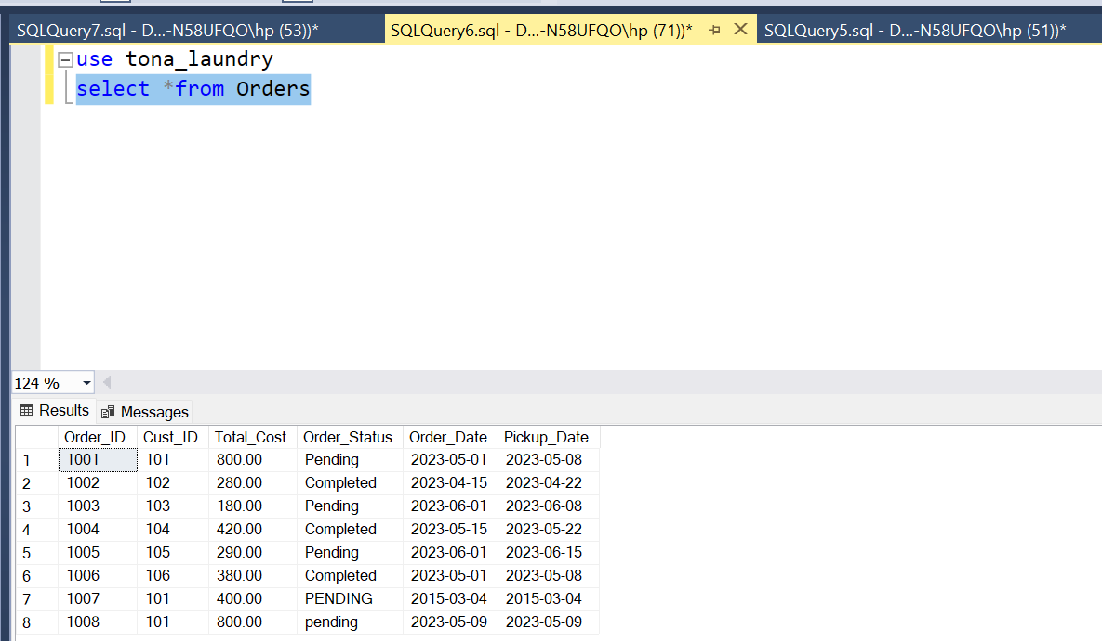

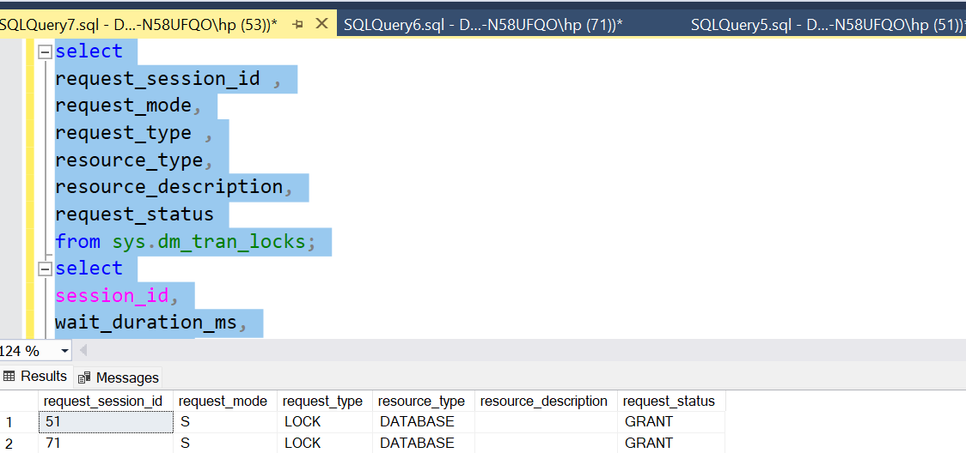
Case 2
1st transaction acquired exclusive lock on table The same 2nd transaction acquired shared lock on the table so the second transaction cant access the table before 1st transaction unlocked . because both lock are not compatible.
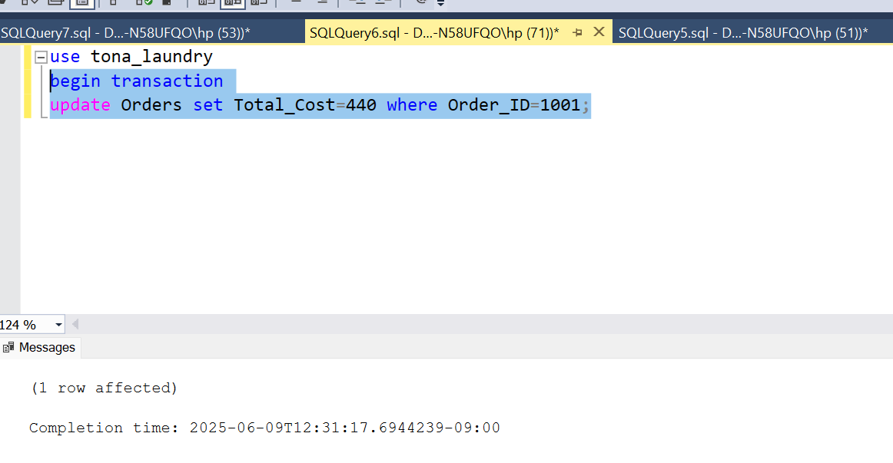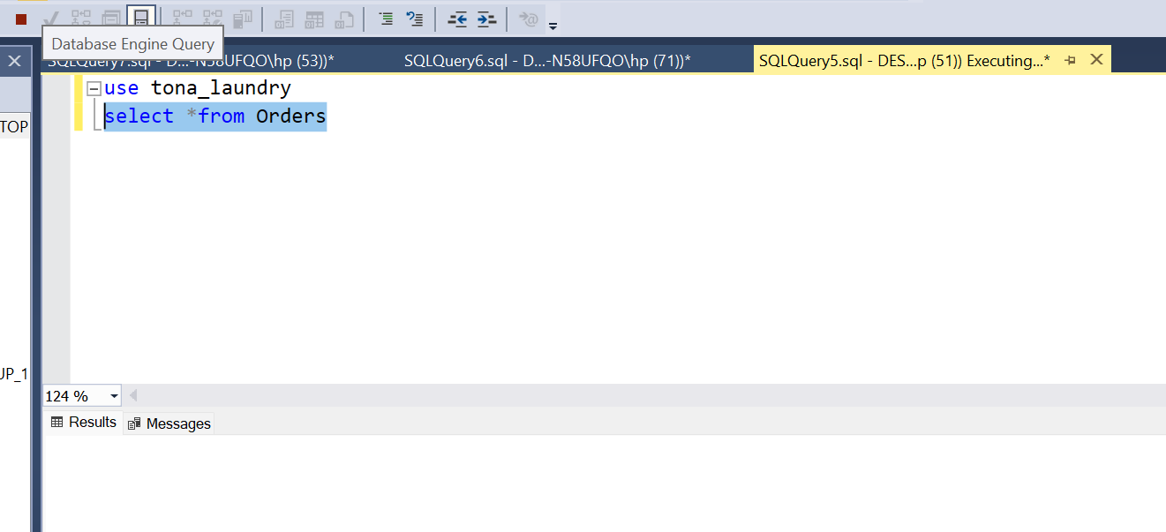
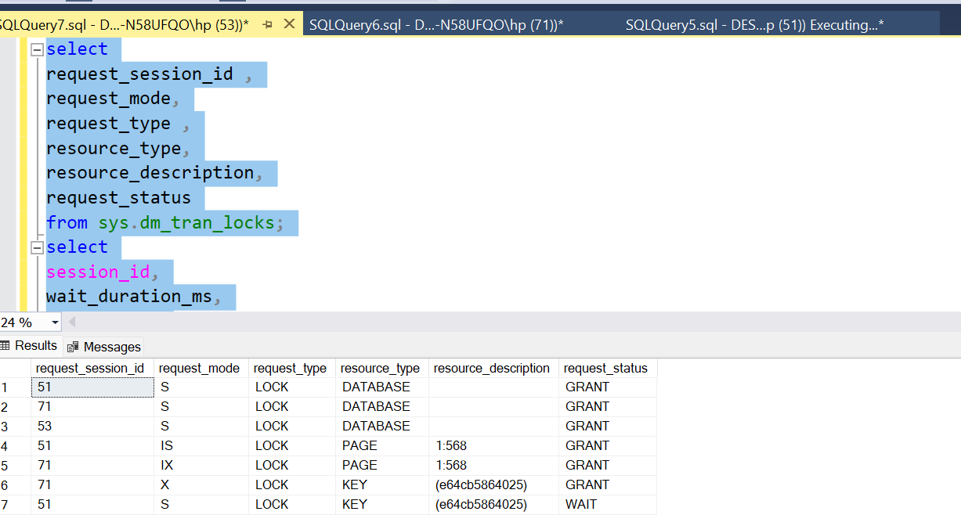

5 . Implement discretionary access control by granting and revoking privilages to users.
--- For access control in discretionary we create login to grant and revoke the privilege for user that logging by created login.
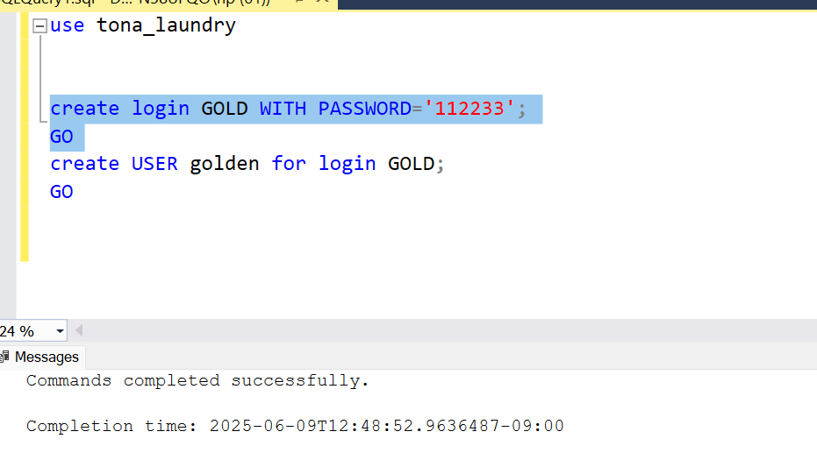
--- To create user
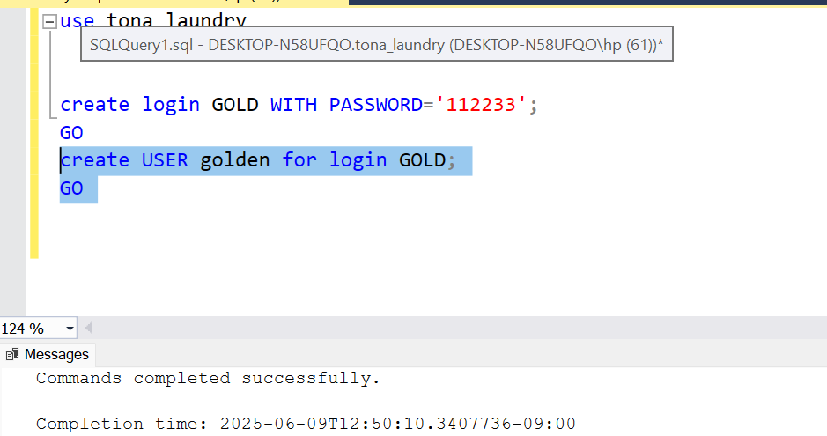
--- Then add role to the user that entered in created login
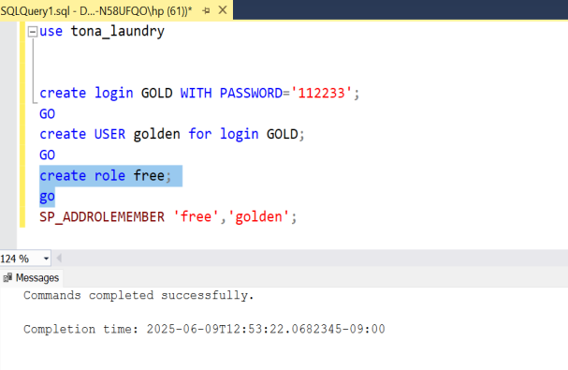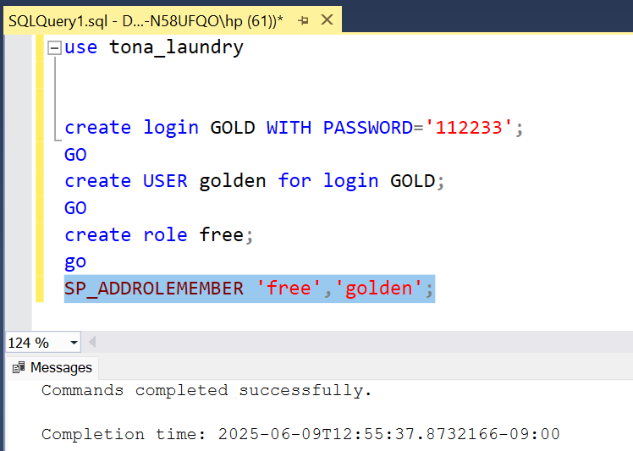
---our created login is HERE
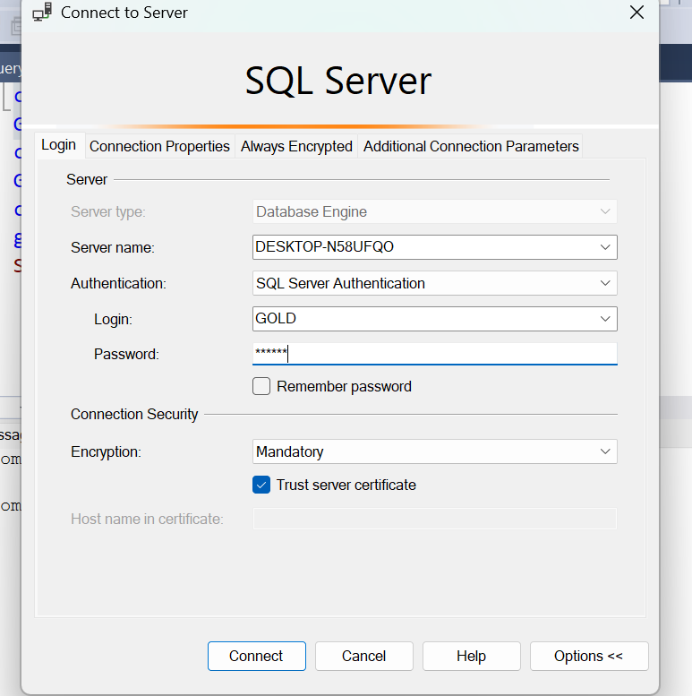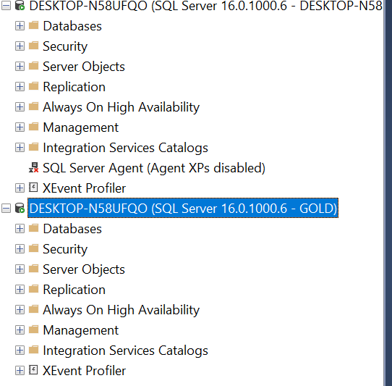
---- Then finally grant privilege for the users those use this login
By using command
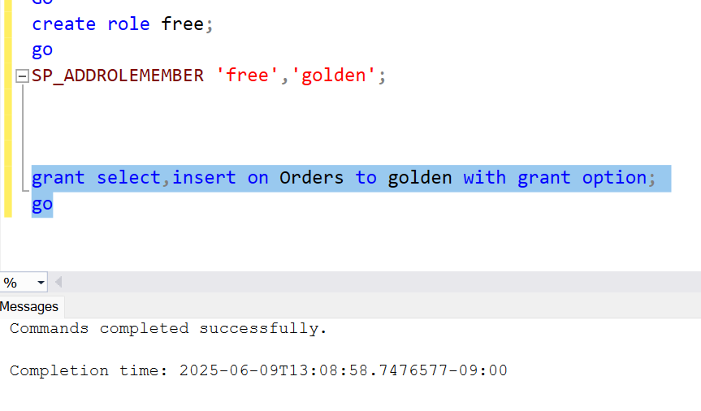
------ The user which use our created login can select the table or have privilage to retrieve the table.
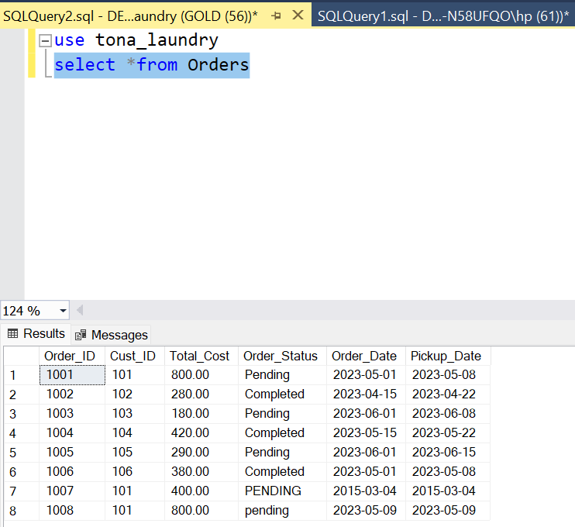
----know we see how we revoke or cancel this privilege
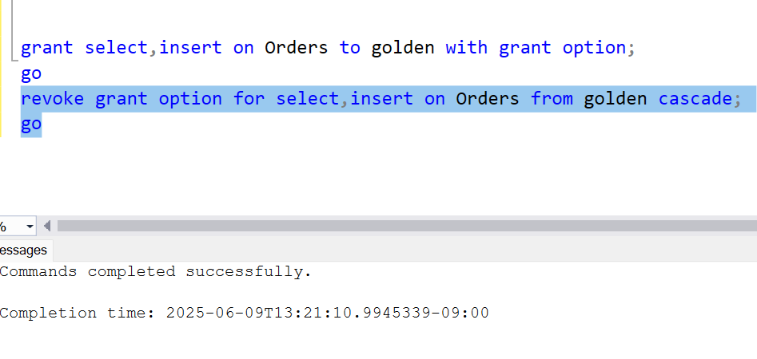
-----So we can’t select or insert data on table by using this login
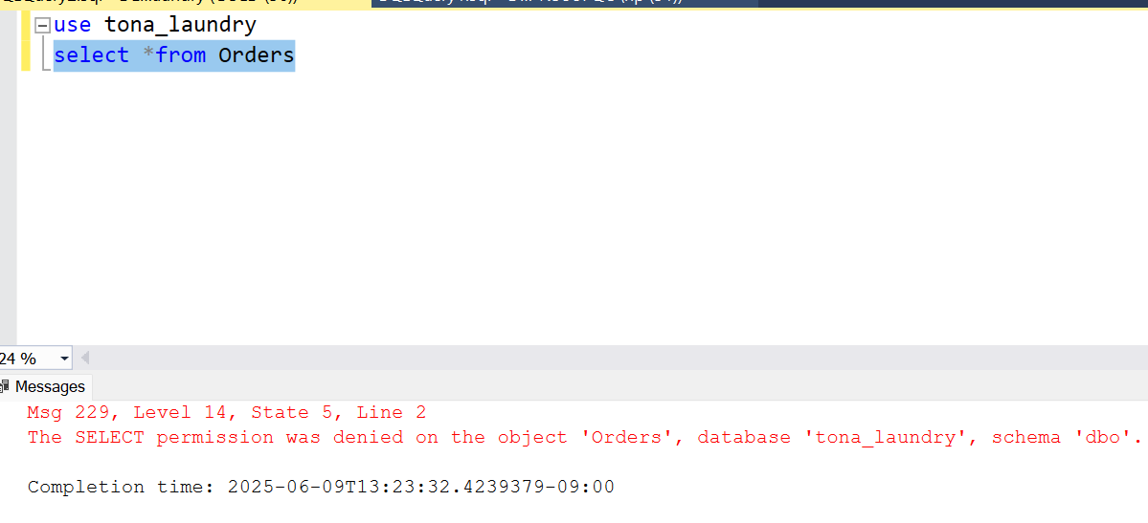

CONCLUSION

In conclusion, the Laundry Database System effectively demonstrates the core principles of relational database design and transactional control tailored to a real-world service environment. Through the development of structured tables and relationships, the system ensures efficient data handling for customers, orders, and payments. Critical operations are securely managed using transaction control mechanisms, including commit, rollback, and save points, to maintain data consistency and handle failures gracefully. Simulated concurrent transactions further showcase the importance of concurrency control techniques in preventing data anomalies and ensuring reliable multi-user access. This comprehensive implementation highlights the practical significance of database design and transaction management in maintaining the integrity and performance of modern service-based applications.

